**Project Planning Phase Sprint Delivery Plan**

|  |  |
| --- | --- |
| **date** | **22 october 2022** |
| **Team ID** | **PNT2022TMID17342** |
| **Project name** | **IOT BASED SMART CROP PROTECTION SYSTEM FOR AGRICALTURE** |
| **Maximum marks** | **8 marks** |

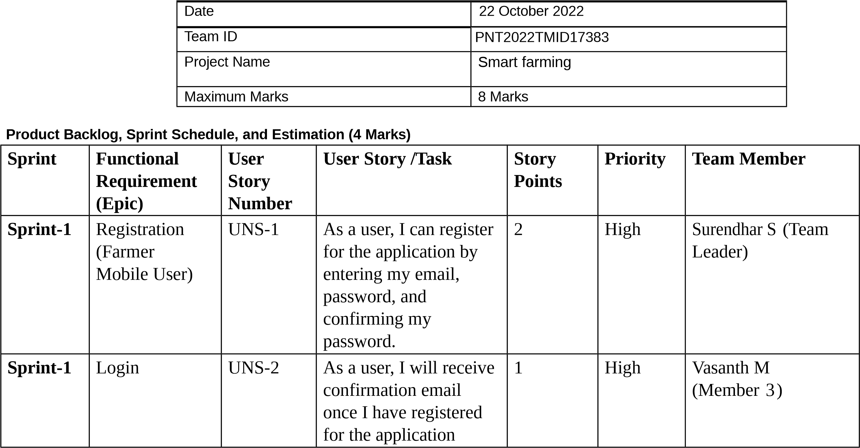

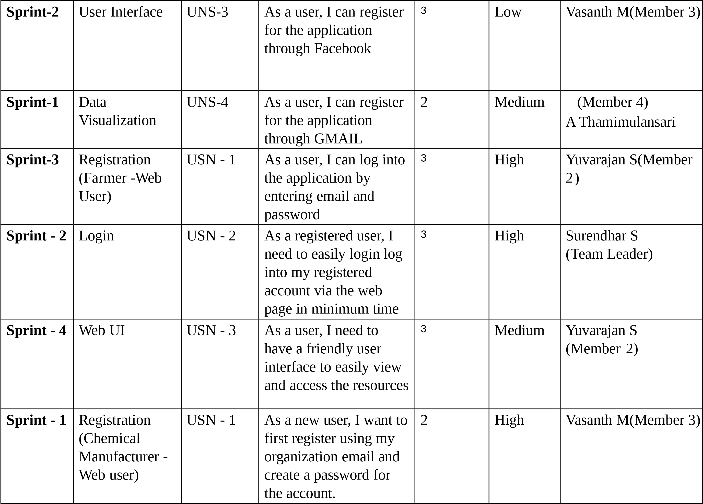

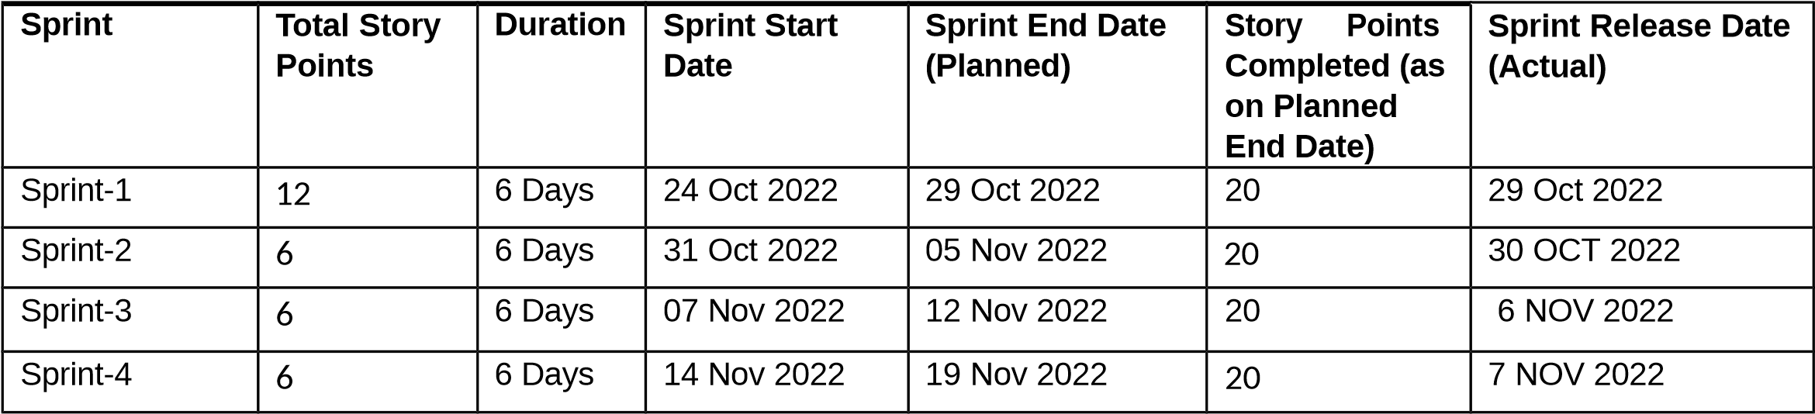

**Sprint**

**-**

**4**

Login

USN

-

2

As

a

registered

user,

I

need

to

easily

log

in

using

the

registered

account

via

the

web

page.

3

High

A Thamimulansari

Member

(

4)

**Sprint**

**-**

**3**

Web

UI

USN

-

3

As

a

user,

I

need

to

have

a

userfriendly

interface

to

easily

view

and

access

the

resources.

3

Medium

A Thamimulansari

(

Member

4

)

**Sprint**

**-**

**1**

Registration

(

Chemical

Manufacturer

-

Mobile

User)

USN

-

1

As

a

user,

I

want

to

first

register

using

my

email

and

create

a

password

for

the

account.

1

High

Surendhar S

)

Team Leader

(

**Sprint**

**-**

**1**

Login

USN

-

2

As

a

registered

user,

I

need

to

easily

log

in

to

the

application.

2

Low

Yuvarajan S

(

Member

2)

**Project**

**Tracker,**

**Velocity**

**&**

**Burn down**

**Chart:**

**(4 Marks)**

**Velocity:**

AV for sprint 1= Sprint Duration /velocity =12/6=2

AV for sprint 2= Sprint Duration/Velocity=6/6=1 AV for Sprint 3=Sprint Duration/Velocity=6/6=1 AV for Sprint 4=Sprint Duration/Velocity=6/6=1

**Burndown Chart:**



